Fine Motor: This week we are focusing on improving prewriting/writing skills.
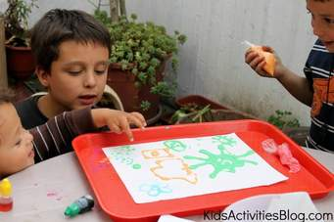 | Prewriting/Writing Activities: Prewriting/Writing activities can be done using a variety of tools and materials. The easiest way is to have your child make a fist then point with their index finger. Children don’t always go through a linear developmental sequence and we don’t want to hold them back from one aspect if they can do another. Example, if they can’t hold a pencil/crayon/marker correctly we might modify the pencil with a primary size pencil with 3 sides or maybe a pencil grip so that they can continue working on tracing from 1 sticker to another, drawing shapes, etc.
Sequences for:
--Prewriting/Writing: Making circular scribbles to vertical and horizontal lines, circles, crosses, squares and triangles; Drawings; Making letters—typically capital letters (upper-case).
--Pencil Grasp: Full hand grasp; Holding more with fingers on the thumb-index finger side of the hand, (the fingers on the little finger side of the hand should be closed into the palm).
A few ideas to get you started:
- Using index finger to trace around shapes on a piece of paper or to the refrigerator (vertical writing), ex. Plastic lid.
- Trace around various objects that are flat, ex. you can trace around the outside of a lid, but the easiest is to trace inside the lid that has a shape has been cut inside the lid. If they have a difficulty time holding the object down you could tape the lid or object down.
- Make shapes/letters with playdoh.
- Draw on sides of bathtub with shaving cream, tub chalk, etc.
- Draw circles around stickers and then make vertical lines to make them look like balloons.
- Rainbow Writing: Offer child either a blue, yellow or pink highlighter. Asked them what color they’d like you to use. You make the line and then they trace over it to change the color—will turn out either purple, orange or green. They are NOT supposed to color in the line but rather to draw over top of it and if it goes off the line that’s okay.
- Trace over highlighted lines (straight, curvy, shapes, letters) with another color highlighter to connect stickers together. Sidewalk chalk.
HAVE FUN!!! WE WOULD LOVE TO HEAR WHAT YOU DID AND/OR INVENTED. SEND PICTURES.

